Charles Pelletier-Gagné
[Address line]
[City, State/Province, Postal Code]
[Email address]

15 February 2026

Professor Péter Ferdinandy
Editor-in-Chief
British Journal of Pharmacology
British Pharmacological Society

Re: Submission of review article — “Terpene pre-loading: a cross-botanical framework for enhancing cannabinoid pharmacology through temporal sequencing of inhaled terpenoids”

Dear Professor Ferdinandy,

I am pleased to submit the enclosed manuscript for consideration as a review article in the British Journal of Pharmacology. The paper proposes and formalises the concept of “terpene pre-loading” — the temporally sequenced inhalation of botanically sourced terpenoids prior to cannabinoid administration — as a testable strategy for resolving the bioavailability gap that has limited the clinical translation of the entourage effect.
I believe the BJP is the natural home for this work for several reasons. The journal published Russo’s seminal 2011 review “Taming THC: potential cannabis synergy and phytocannabinoid-terpenoid entourage effects,” which remains the most cited paper on the phytocannabinoid-terpenoid entourage effect and serves as the foundational framework that this manuscript directly extends. The BJP’s readership encompasses the precise community — cannabinoid pharmacologists, terpenoid researchers, and receptor biologists — who would evaluate, refine, and ultimately test the pre-loading hypothesis. The journal’s history of publishing theoretical and hypothesis-generating papers within the cannabinoid pharmacology field makes it an ideal venue for this proposal.
The manuscript synthesises three historically separated literatures — cannabis pharmacology, clinical aromatherapy, and forest bathing immunology — to make a straightforward but previously unformulated argument: because terpene molecules are pharmacologically identical regardless of botanical origin, the bioavailability constraints of cannabis flower can be overcome by supplementing terpene exposure with essential oil inhalation from non-cannabis sources. This “cross-botanical entourage effect” is, to my knowledge, not proposed or formalised anywhere in the existing literature.
The timing of this submission is informed by two landmark studies published in 2024. First, Spindle, Vandrey, and Russo demonstrated in a double-blind human trial that vaporised d-limonene dose-dependently mitigates THC-induced anxiety (Drug and Alcohol Dependence, 2024) — the first clinical evidence for a specific terpene modulating a specific cannabinoid effect. Second, Schwarz and colleagues in Streicher’s laboratory showed that cannabis terpenes produce morphine-equivalent analgesia via spinal cord adenosine A2a receptors (PAIN, 2024), resolving the prior contradiction between positive behavioural findings and negative receptor-binding studies. Together, these papers establish the pharmacological reality of terpene-cannabinoid interaction and identify the A2a receptor system as a critical mediating mechanism — both of which are foundational to the pre-loading hypothesis.
Rather than merely proposing a concept, the manuscript provides five specific falsifiable predictions and detailed experimental protocols for both preclinical (mouse tetrad assay with terpene pre-exposure) and clinical (four-condition, within-subjects, double-blind crossover at a facility such as the Johns Hopkins Behavioral Pharmacology Research Unit) validation. The A2a-CB1 receptor heteromer system is proposed as the molecular site of convergence, supported by independent evidence from the receptor heteromer literature. The paper includes three figures: a conceptual pathway model, a quantitative dose-gap analysis, and the complete clinical trial design.
If the pre-loading hypothesis is validated, the implications extend beyond cannabinoid pharmacology. The concept of using broad-spectrum natural products to prime receptor systems before targeted drug delivery represents a general pharmacological strategy with applications in multi-target therapeutics. More immediately, essential oil pre-loading could offer a practical strategy for optimising cannabinoid therapy — enabling lower effective doses while maintaining therapeutic efficacy and reducing adverse effects such as THC-induced anxiety.
The manuscript has not been published previously and is not under consideration at any other journal. I have no conflicts of interest to declare. No external funding was received for this work. The manuscript contains approximately 7,200 words (excluding references and figure legends), 51 references, and 3 figures, which falls within the BJP’s guidelines for review articles.
Suggested reviewers:
1. Professor John M. Streicher, Department of Pharmacology, University of Arizona (jstreicher@arizona.edu) — Principal investigator of the LaVigne et al. (2021) and Schwarz et al. (2024) studies central to this manuscript.
2. Dr Tory R. Spindle, Johns Hopkins University School of Medicine — Lead author of the 2024 human d-limonene/THC trial, with direct expertise in the clinical paradigm proposed here.
3. Professor Mark Moss, Department of Psychology, Northumbria University (mark.moss@northumbria.ac.uk) — Leading researcher on inhaled terpenoid bioavailability and cognitive effects, whose plasma 1,8-cineole findings are foundational to the inhalation pharmacokinetics argument.
4. Professor Jürg Gertsch, Institute of Biochemistry and Molecular Medicine, University of Bern (juerg.gertsch@unibe.ch) — Discoverer of β-caryophyllene as a dietary cannabinoid; his CB2 receptor work is central to the molecular identity thesis.

I appreciate your consideration of this submission and look forward to your response.

Sincerely,

Charles Pelletier-Gagné

Terpene pre-loading: a cross-botanical framework for enhancing cannabinoid pharmacology through temporal sequencing of inhaled terpenoids

Charles Pelletier-Gagné

Running title: Terpene pre-loading and cannabinoid pharmacology

Corresponding author: Charles Pelletier-Gagné
Email: [corresponding author email]

Keywords: terpenes, entourage effect, cannabinoids, adenosine A2a, aromatherapy, bioavailability, pre-loading

Word count: ~7,200 (excluding references and figure legends)
Number of figures: 3
Number of references: 51

Abstract
Cannabis terpenes produce cannabimimetic effects via CB1, CB2, and adenosine A2a receptors, yet their concentrations in flower (1–4% by weight) fall far below the doses required for reliable pharmacological activity in preclinical models. This review proposes “terpene pre-loading”—the temporally sequenced inhalation of botanically sourced terpenoids prior to cannabinoid administration—as a strategy for bridging the bioavailability gap that has limited the clinical translation of the entourage effect. We synthesize three historically separated literatures—cannabis pharmacology, aromatherapy clinical research, and forest bathing immunology—to demonstrate that identical terpene molecules produce convergent receptor-level effects regardless of botanical origin. Drawing on recent evidence that inhaled terpenoids achieve pharmacologically relevant brain concentrations and that terpene-cannabinoid interactions are selectively additive, we propose specific testable predictions and experimental protocols for validating the pre-loading hypothesis.

Introduction: The Entourage Effect at a Crossroads
The hypothesis that cannabis terpenoids modulate and enhance the pharmacological activity of phytocannabinoids—commonly termed the “entourage effect”—has occupied a contested position in cannabinoid pharmacology for over two decades. The concept was first articulated by Mechoulam and Ben-Shabat in the context of endocannabinoid signalling,¹ and subsequently elaborated by Russo in a comprehensive review published in this journal, which remains the most cited paper on phytocannabinoid-terpenoid synergy.² That 2011 framework proposed specific therapeutic synergies between individual terpenoids and cannabinoids, drawing on pharmacological, preclinical, and anecdotal evidence to argue that the whole cannabis plant produces outcomes that purified cannabinoids cannot replicate.
In the fifteen years since, the entourage effect has become a central organizing principle for the legal cannabis industry, driving the premium pricing of “full-spectrum” products and the emergence of terpene-forward retail curation.³ Yet the scientific evidence has remained frustratingly ambiguous. The debate has been shaped by a fundamental tension between two categories of findings. On one hand, several preclinical studies have demonstrated that cannabis terpenes produce measurable pharmacological effects and interact with cannabinoid signalling in ways consistent with the entourage hypothesis.^{4,5} On the other hand, attempts to demonstrate direct terpene modulation of cannabinoid receptor binding have yielded null results,⁶ leading some investigators to conclude that the entourage effect, at least as mediated through CB1 and CB2, lacks empirical support.
Two developments in 2024 transformed this landscape. First, Spindle, Vandrey, and Russo published the first double-blind, placebo-controlled human trial demonstrating that vaporized d-limonene dose-dependently mitigates THC-induced anxiety without altering other subjective or physiological effects of THC.⁷ This study provided the first clinical evidence that a specific terpene modulates a specific cannabinoid effect in humans. Second, Schwarz and colleagues in Streicher’s laboratory demonstrated that cannabis terpenes produce antinociception equivalent to low-dose morphine via spinal cord adenosine A2a receptors—not cannabinoid receptors.⁸ This finding elegantly resolved the apparent contradiction between the Finlay null result⁶ and the LaVigne positive behavioural findings:⁴ terpenes produce cannabimimetic effects, but they do so primarily through non-cannabinoid receptor pathways that interact with cannabinoid signalling at the systems level.
These breakthroughs validate the pharmacological reality of terpene-cannabinoid interaction. But they also foreground a problem that has received insufficient attention: the bioavailability gap. The doses producing reliable terpene effects in preclinical models—typically 50–200 mg/kg in mice⁴—far exceed what humans receive from consuming cannabis flower, where total terpene content ranges from 1–4% by weight^{2,9} and is further diminished by thermal degradation during combustion or vaporization. A 2025 review explicitly acknowledged that preclinical terpene doses are “substantially higher than those attainable through cannabis flower consumption (≤20 mg total).”¹⁰
This review proposes a resolution to the bioavailability problem that draws on evidence from outside the cannabis pharmacology literature. Specifically, we argue that the artificial disciplinary separation between cannabis terpene research, clinical aromatherapy, and forest bathing immunology has obscured a straightforward pharmacological strategy: supplementing cannabis-derived terpene exposure with inhalation of botanically sourced essential oils containing the same terpenoid molecules. We term this strategy “terpene pre-loading” and propose it as a testable hypothesis with specific predictions and experimental protocols.
The Molecular Identity Thesis: Terpenes Across Botanical Sources
The pharmacological foundation of the pre-loading hypothesis rests on a claim that is chemically uncontroversial but has been insufficiently appreciated in its practical implications: a terpene molecule is identical regardless of its botanical origin. Linalool from Lavandula angustifolia and linalool from Cannabis sativa share the same molecular formula (C₁₀H₁₈O), the same structural configuration, and the same receptor binding profile. When linalool engages a GABA-A receptor in the human central nervous system, the receptor does not distinguish between lavender and cannabis as the molecular source.¹¹
This molecular identity has been demonstrated most rigorously for β-caryophyllene, the sesquiterpene identified by Gertsch and colleagues as the first dietary cannabinoid.¹² (E)-β-caryophyllene selectively binds the human CB2 receptor (K_{i} = 155 ± 4 nM) and functions as a full agonist, inhibiting adenylate cyclase, triggering intracellular calcium transients, and activating MAP kinases Erk1/2 and p38 in human monocytes.¹² This activity is identical whether the β-caryophyllene derives from Cannabis essential oil, black pepper (Piper nigrum), cloves (Syzygium aromaticum), or rosemary (Rosmarinus officinalis). At 5 mg/kg, oral (E)-β-caryophyllene substantially reduces carrageenan-induced inflammation in wild-type mice but not in CB2-knockout mice, confirming receptor-dependent activity.¹²
Similar source-independence applies to other pharmacologically active terpenoids. d-Limonene functions as an agonist at adenosine A2a receptors regardless of whether it derives from citrus peel or cannabis.¹³ Linalool produces anxiolytic effects through GABA-A modulation when inhaled from lavender¹⁴ or when administered as a cannabis-derived compound.¹¹ α-Pinene inhibits acetylcholinesterase and enhances memory through BDNF/TrkB/CREB signalling whether sourced from pine forests, rosemary, or cannabis.¹⁵
Despite this chemical identity, terpene pharmacology has been studied through three largely isolated research traditions. Cannabis researchers publish in journals such as this one, Frontiers in Pharmacology, and Scientific Reports. Aromatherapy researchers publish in Phytomedicine, the International Journal of Molecular Sciences, and Human Psychopharmacology. Forest bathing researchers publish in Environmental Health and Preventive Medicine. The three communities read different journals, attend different conferences, and cite different foundational papers—all for the same underlying phenomenon: inhaled terpenoids interacting with human receptor systems. The result is a fragmented evidence base in which each field has produced genuine insights, but the synthesis necessary to resolve the bioavailability problem has been delayed by disciplinary boundaries.
The Bioavailability Problem: Dose-Gap Analysis
The central obstacle to the clinical translation of the entourage effect is quantitative, not mechanistic. The LaVigne study demonstrated that α-humulene, geraniol, linalool, and β-pinene, administered at 200 mg/kg intraperitoneally in mice, produce the full cannabinoid tetrad: hypolocomotion, catalepsy, hypothermia, and antinociception.⁴ These behaviours were blocked by the CB1 antagonist rimonabant, confirming cannabinoid receptor involvement, and were selectively additive when combined with the synthetic cannabinoid WIN55,212-2.⁴ The Schwarz study extended these findings to demonstrate morphine-equivalent analgesia at comparable doses, mediated through spinal cord A2a receptors.⁸
These are compelling mechanistic findings. But 200 mg/kg in a 25 g mouse corresponds to 5 mg of terpene administered to a single animal. Scaled allometrically to a 70 kg human, the equivalent dose is on the order of grams—a quantity vastly exceeding what cannabis flower can deliver. A typical high-quality cannabis flower contains 2–3% total terpenes by weight.² A standard 0.5 g consumption session therefore contains approximately 10–15 mg of total terpenes, distributed across 10–20 individual compounds. The dominant terpene in any given chemovar typically constitutes 0.3–1.0% of flower weight, yielding 1.5–5 mg per session.⁹ Factor in combustion losses (which can degrade 30–50% of volatile terpenoids¹⁶), incomplete inhalation, and rapid systemic clearance, and the terpene dose reaching receptor sites from cannabis consumption is a fraction of what preclinical models require for reliable pharmacological effects.
This dose gap has fuelled scepticism about the clinical relevance of the entourage effect.^{6,10} If the terpene concentrations achievable through cannabis flower are below pharmacological thresholds for most terpenoids, then whole-plant synergy may be limited to the minority of compounds (such as β-caryophyllene) with sufficient potency to produce effects at very low concentrations, or may be entirely attributable to placebo and expectation effects.
However, this conclusion rests on the implicit assumption that cannabis flower is the only relevant source of terpene exposure. The pre-loading hypothesis challenges this assumption by introducing a second terpene delivery pathway: inhalation of essential oils via diffusion, which produces systemic terpene exposure that substantially exceeds what cannabis flower alone can provide.
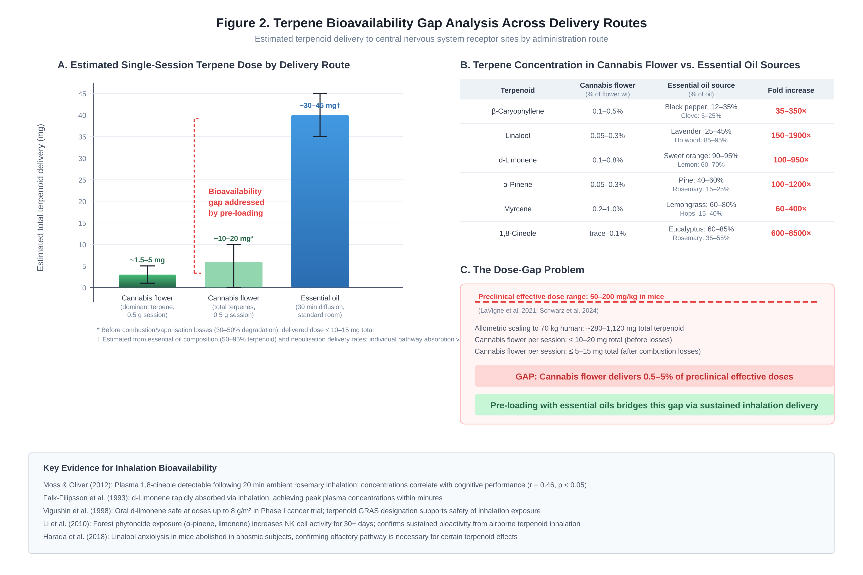
Figure 2. Terpene bioavailability gap analysis across delivery routes. (A) Estimated single-session terpene dose by delivery route, comparing cannabis flower dominant terpenoid (~1.5–5 mg), total cannabis terpenes (~10–20 mg before combustion losses), and essential oil diffusion (~30–45 mg over 30 minutes). (B) Compound-by-compound comparison of terpenoid concentrations in cannabis flower versus essential oil sources, showing 35–8,500-fold concentration advantages. (C) Quantification of the dose-gap problem: cannabis flower delivers 0.5–5% of preclinical effective doses (50–200 mg/kg in mice). Pre-loading with essential oils is proposed to bridge this gap.
Three Convergent Receptor Pathways for Inhaled Terpenoids
The pharmacological plausibility of the pre-loading hypothesis depends on whether inhaled terpenoids from essential oil diffusion can reach central nervous system receptor targets at pharmacologically relevant concentrations. Three delivery pathways have been characterised, each supported by independent lines of evidence.
Olfactory-limbic signalling
The olfactory nerve is unique among cranial nerves in its direct anatomical connection to the limbic system, bypassing thalamic relay.¹⁷ When volatile terpenoids bind to olfactory receptors in the nasal epithelium, the resulting signals propagate directly to the amygdala, hippocampus, and hypothalamus—brain regions governing emotion, memory, and autonomic regulation.^{17,18} This pathway does not require systemic absorption or blood-brain barrier penetration; it operates through neuronal signalling rather than molecular transport. The olfactory-limbic pathway is rapid (effects measurable within minutes of exposure) and has been demonstrated to produce physiological changes including reduced cortisol, altered autonomic tone, and modified EEG patterns.^{19,20} Critically, Harada and colleagues demonstrated that linalool-induced anxiolysis in mice is abolished in anosmic animals, confirming that the olfactory pathway is necessary for at least some terpenoid effects.¹¹ Schneider’s large-scale human study (n = 465) further demonstrated that functional olfactory processing is required for aromatherapy effects, with anosmic participants showing no physiological response to essential oil inhalation.²⁰
Direct neuronal transport
Beyond signalling, small volatile molecules can be physically transported from the nasal cavity to the brain through intracellular and extracellular pathways along the olfactory and trigeminal nerves.^{18,21} Fung and colleagues reviewed these pathways comprehensively, describing how inhaled molecules undergo receptor-mediated endocytosis at olfactory sensory neurones and are transported via anterograde mechanisms to the olfactory cortex, with subsequent projections to the hippocampus and amygdala.¹⁸ Extracellular transport occurs through the paracellular cleft to the lamina propria, with subsequent passage along perineuronal spaces to the brain parenchyma and across the blood-brain barrier and blood-cerebrospinal fluid barrier.¹⁸ This pathway delivers intact terpenoid molecules to brain tissue, enabling direct receptor engagement.
Pulmonary-circulatory absorption
The third pathway involves classical pharmacokinetic absorption: inhaled terpenoid molecules dissolve into the respiratory epithelium, diffuse to the alveoli, and enter the systemic circulation for transport to the brain.¹⁸ The critical evidence for this pathway comes from Moss and Oliver, whose landmark study demonstrated that plasma concentrations of 1,8-cineole (the primary terpenoid in rosemary essential oil) measured following ambient inhalation correlated significantly with cognitive performance on memory and attention tasks.²² This was the first study to demonstrate that an inhaled terpenoid achieves pharmacologically relevant blood concentrations through passive environmental exposure and that those concentrations predict functional central nervous system effects. Recent work by Moss using functional near-infrared spectroscopy (fNIRS) has directly measured brain metabolic changes during essential oil aroma exposure, providing neuroimaging evidence for central terpenoid activity following inhalation.²³
Together, these three pathways establish that essential oil diffusion delivers terpenoid molecules to the central nervous system through complementary mechanisms, with the olfactory-limbic pathway providing rapid signalling effects and the pulmonary-circulatory pathway providing sustained molecular delivery. The total terpenoid exposure achievable through 15–30 minutes of essential oil diffusion in a standard room substantially exceeds what any quantity of cannabis flower can provide, because essential oils are concentrated terpenoid preparations (typically 50–95% terpenoid content by weight) delivered continuously over a prolonged inhalation period.
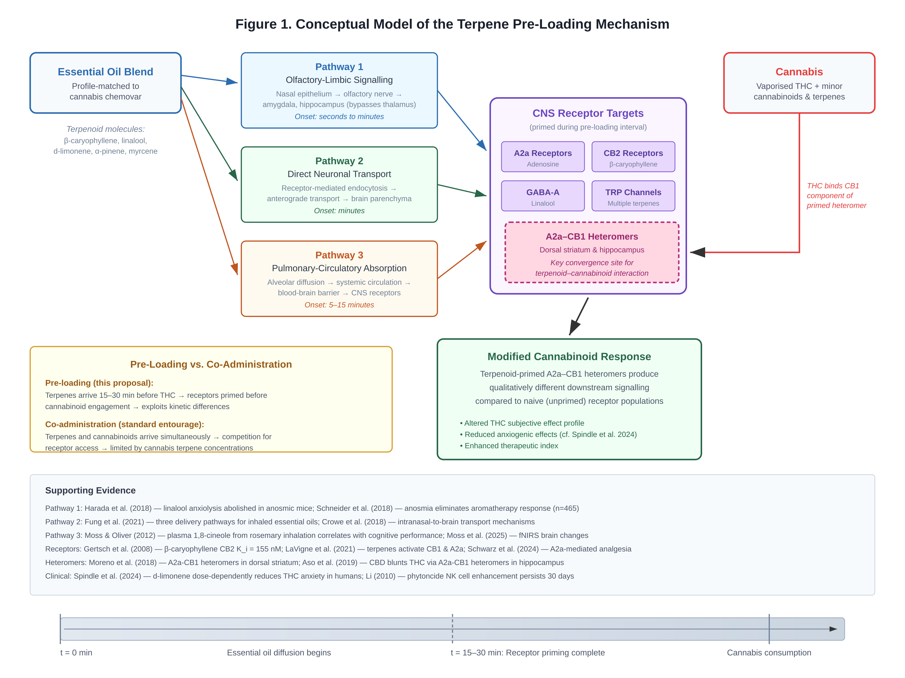
Figure 1. Conceptual model of the terpene pre-loading mechanism. Three receptor pathways by which inhaled terpenoids reach the central nervous system (olfactory-limbic signalling, direct neuronal transport, and pulmonary-circulatory absorption) converge with subsequent cannabinoid activation. The pre-loading interval (15–30 minutes) allows terpenoid-sensitive receptor systems, particularly A2a receptors, to be primed before THC engages CB1 receptors. A2a–CB1 heteromer interactions in the dorsal striatum represent the proposed site of convergence.
The Pre-Loading Hypothesis: Temporal Sequencing as Pharmacological Strategy
The convergence of the evidence reviewed above—that terpene molecules are pharmacologically identical across botanical sources, that cannabis flower delivers sub-threshold terpene doses for many pharmacological endpoints, and that essential oil inhalation achieves central nervous system terpenoid concentrations through three complementary pathways—leads to the central proposal of this review.
We define terpene pre-loading as the temporally sequenced inhalation of botanically sourced terpenoids, formulated to match the terpene profile of a target cannabis chemovar, administered 15–30 minutes prior to cannabinoid consumption. The pre-loading interval is designed to saturate terpenoid-sensitive receptor systems before THC and other phytocannabinoids arrive, creating a modified receptor landscape in which cannabinoid signalling is modulated by prior terpenoid activity.
The mechanistic rationale rests on the multi-target pharmacology of terpenoids revealed by recent research. Because terpenes activate A2a receptors,^{8,13} GABA-A receptors,¹¹ TRP channels,²⁴ and possibly CB1 and CB2 receptors^{4,12} through distinct mechanisms, pre-loading engages a receptor constellation that is partially overlapping with, but not identical to, the targets of subsequent cannabinoid administration. The critical interaction point may be the A2a-CB1 receptor heteromer system.
Adenosine A2a and cannabinoid CB1 receptors form functional heteromers in the dorsal striatum, where they exhibit bidirectional modulation of signalling.²⁵ A2a activation modifies the pharmacological properties of co-expressed CB1 receptors, altering agonist potency and downstream signalling cascades.^{25,26} Aso and colleagues demonstrated that A2a-CB1 heteromers in the hippocampus mediate the interaction between adenosinergic and cannabinoid signalling, with CBD blunting THC-induced cognitive impairment through this heteromeric mechanism.²⁷ Memory deficits induced by chronic cannabinoid exposure can be prevented by A2a receptor antagonism, further establishing the functional interdependence of these receptor systems.²⁸
The pre-loading hypothesis proposes that terpenoid activation of A2a receptors during the 15–30 minute inhalation interval modifies the conformational state and signalling properties of A2a-CB1 heteromers, such that subsequent THC binding to the CB1 component of the heteromer produces qualitatively or quantitatively different downstream effects compared to conditions in which THC engages a naive (non-terpenoid-primed) receptor population. This is distinct from simple co-administration, in which terpenes and cannabinoids arrive simultaneously and compete for receptor access. Temporal sequencing allows the terpenoid to establish a receptor state before the cannabinoid arrives, exploiting the kinetic differences between fast terpenoid signalling (via the olfactory-limbic pathway) and slower cannabinoid absorption.
The proposed pre-loading protocol uses essential oil blends formulated to match the dominant terpenoid profile of the target cannabis chemovar. For a high-linalool strain, the blend would be lavender-dominant. For a high-β-caryophyllene strain, the blend would feature black pepper and clove oils. For a high-limonene strain, citrus oils would predominate. This profile-matching approach ensures that the pre-loaded terpenoids engage the same receptor subsets that the cannabis-derived terpenoids would subsequently activate, creating receptor-level continuity across the botanical transition. The essential oil blend is diffused via ultrasonic nebulisation for 15–30 minutes in the consumer’s environment prior to cannabis consumption.
Proposed Experimental Protocols
The pre-loading hypothesis generates specific, falsifiable predictions that can be tested through a phased research programme combining preclinical and clinical investigation.
Preclinical protocol
Building on the LaVigne and Schwarz paradigms from the Streicher laboratory at the University of Arizona,^{4,8} the preclinical arm would test whether terpene pre-exposure modifies subsequent cannabinoid-mediated behaviours in mice. Three conditions would be compared using the cannabinoid tetrad assay (locomotion, catalepsy, body temperature, tail-flick antinociception): (a) terpene inhalation 20 minutes prior to WIN55,212-2 injection (pre-loaded); (b) simultaneous terpene inhalation and WIN55,212-2 injection (co-administered); (c) vehicle inhalation followed by WIN55,212-2 injection (cannabinoid-only control). An additional control would administer terpene inhalation followed by vehicle injection to isolate terpene-only effects.
The critical comparison is between conditions (a) and (b). If pre-loading produces different effect profiles from co-administration, this would demonstrate that temporal sequencing matters—that the order of receptor engagement, not merely the total terpenoid-cannabinoid exposure, determines pharmacological outcomes. Mechanistic specificity would be assessed by repeating the protocol in the presence of the A2a antagonist istradefylline⁴ and the CB1 antagonist rimonabant. If pre-loading effects are attenuated by A2a antagonism but not by CB1 antagonism during the pre-loading interval, this would support the A2a priming hypothesis. The LaVigne data already suggest this dissociation: rimonabant reversed some but not all terpene-induced behaviours, while A2a antagonism contributed to others.⁴
Human clinical protocol
The clinical arm would adapt the paradigm established by Spindle and Vandrey at the Johns Hopkins Behavioral Pharmacology Research Unit,⁷ which possesses the regulatory infrastructure and experience necessary for administering cannabinoids and terpenoids to human participants. A within-subjects, double-blind, placebo-controlled crossover design would compare four conditions: (a) standardised essential oil inhalation for 20 minutes followed by vaporized THC (pre-loaded); (b) simultaneous essential oil diffusion during vaporized THC administration (co-administered); (c) placebo oil inhalation followed by vaporized THC (THC-only control); (d) essential oil inhalation followed by placebo vapour (terpene-only control).
Primary outcome measures would include the Drug Effects Questionnaire (assessing subjective drug effects including anxiety, liking, and perceived drug strength), visual analogue scales for specific effect domains, and physiological measures (heart rate, blood pressure, cortisol). Secondary outcomes would include a cognitive battery (attention, working memory) and quantitative sensory testing if the analgesic dimension is included. The essential oil blend would be formulated using d-limonene as the primary terpenoid, given its established human safety profile²⁹ and the existing Hopkins data on its interaction with THC.⁷
The incorporation of Moss’s fNIRS methodology²³ during the pre-loading interval would provide real-time neuroimaging data on brain metabolic changes occurring between essential oil onset and cannabinoid administration, offering a direct window into the neurophysiology of receptor priming.
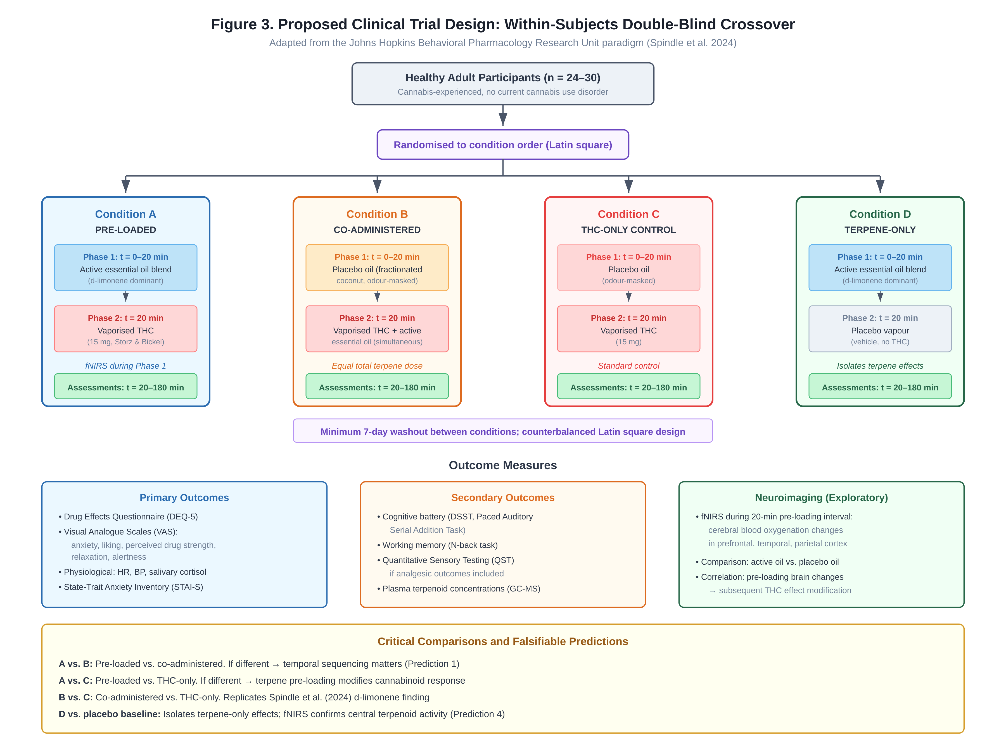
Figure 3. Proposed clinical trial design for the pre-loading study. Within-subjects, double-blind, placebo-controlled crossover with four conditions: (A) essential oil pre-loading followed by vaporised THC; (B) simultaneous essential oil and THC co-administration; (C) placebo oil followed by THC (THC-only control); (D) essential oil followed by placebo vapour (terpene-only control). Minimum 7-day washout between conditions. Primary outcomes include the Drug Effects Questionnaire, visual analogue scales, and physiological measures. Functional near-infrared spectroscopy (fNIRS) during the 20-minute pre-loading interval provides neuroimaging of receptor priming.
Falsifiable predictions
The pre-loading hypothesis makes the following specific predictions, each of which can be independently tested:
Prediction 1: Pre-loaded terpene inhalation followed by THC will produce a different subjective effect profile than simultaneous terpene-THC co-administration, even when total terpene and THC doses are equivalent.
Prediction 2: Pre-loading effects will be partially attenuated by A2a antagonism (istradefylline), supporting A2a receptor priming as a contributing mechanism.
Prediction 3: Anosmic participants will show reduced pre-loading effects mediated by the olfactory-limbic pathway but will retain effects mediated by pulmonary absorption, demonstrating dissociable contributions of the two delivery pathways.
Prediction 4: fNIRS imaging will detect changes in cerebral blood oxygenation during the pre-loading interval that differ from resting baseline and that predict the magnitude of subsequent cannabinoid effect modification.
Prediction 5: Essential oil blends profile-matched to the cannabis chemovar will produce greater effect modification than non-matched blends, supporting the specificity of terpene-cannabinoid interaction rather than a generic aromatic priming effect.
Discussion and Future Directions
The pre-loading framework proposed here represents an extension of the entourage effect hypothesis that addresses its most persistent limitation: the bioavailability gap between preclinical evidence and clinical reality. By introducing a second terpene source—botanically derived essential oils—the framework overcomes the concentration ceiling imposed by the cannabis plant itself, while preserving the molecular identity of the active compounds.
Several limitations require acknowledgement. First, inhaled terpenoids have relatively short half-lives and rapid systemic clearance, which may constrain the effective pre-loading window. The 15–30 minute interval proposed here is based on Moss’s demonstration that plasma terpenoid concentrations and cognitive effects are detectable following ambient rosemary inhalation,²² but the optimal timing will need to be determined empirically. Second, individual variability in olfactory function—which declines with age and is affected by illness, including post-viral anosmia—may influence the magnitude of pre-loading effects, particularly those mediated by the olfactory-limbic pathway. Third, the receptor heteromer hypothesis, while supported by independent evidence for A2a-CB1 interactions,^{25–28} has not been directly tested in the context of terpenoid pre-exposure and remains speculative.
More fundamentally, the pre-loading concept challenges the implicit assumption that the entourage effect must be a within-plant phenomenon—that phytocannabinoid-terpenoid synergy can only arise from compounds co-produced by Cannabis sativa. We propose the term cross-botanical entourage effect for multi-source terpene-cannabinoid interactions in which terpenoids derived from non-cannabis plants modulate cannabinoid pharmacology. This is not pharmacologically novel—it is simply the logical consequence of the molecular identity thesis applied to the entourage hypothesis—but it has not been previously formalised or tested.
The cross-botanical framework also reconnects two research traditions that have been artificially separated by legal and commercial history. Cannabis was criminalised in the United States in 1937; essential oils were not. From that point forward, identical molecules were studied under different legal, regulatory, and cultural frameworks, producing separate literatures that rarely cite each other. The aromatherapy evidence base—including systematic reviews of lavender inhalation across 972 participants demonstrating robust anxiolytic effects,³⁰ the Silexan trials demonstrating lavender oil’s equivalence to paroxetine for generalised anxiety disorder,³¹ and Moss’s series of studies correlating plasma terpenoid levels with cognitive outcomes^{22,23}—constitutes a substantial body of clinical evidence on inhaled terpenoid pharmacology that the cannabis field has largely overlooked.
Similarly, the forest bathing (shinrin-yoku) literature offers ecological-scale evidence for airborne terpenoid bioactivity. Li demonstrated that exposure to phytoncides—volatile terpenoids including α-pinene and limonene released by trees—increases natural killer cell activity in human participants, with effects persisting for up to 30 days.³² These are the same terpenoid molecules found in cannabis, activating the same immune receptors, through the same inhalation pathways. The forest bathing evidence provides an evolutionary context for the pre-loading hypothesis: humans have been exposed to airborne terpenoids throughout evolutionary history, and the receptor systems engaged by inhaled terpenoids may have evolved in environments where multi-source terpenoid exposure was the norm rather than the exception.
The practical implications of the pre-loading concept extend beyond basic pharmacology. If validated, terpene pre-loading could offer a strategy for optimising cannabinoid therapy—enabling lower effective cannabinoid doses while maintaining or enhancing therapeutic efficacy, and potentially reducing unwanted side effects such as THC-induced anxiety. The essential oils used in pre-loading blends are Generally Recognised as Safe (GRAS) by the US FDA,² presenting a favourable regulatory pathway for human research. The established safety profile of essential oil inhalation, combined with the well-characterised pharmacology of the constituent terpenoids, positions the pre-loading protocol as a low-risk, high-information research programme.
The framework also has implications for network pharmacology and multi-target drug design. Terpenoids are, by their nature, polypharmacological agents: individual compounds engage multiple receptor targets at relatively low potencies, producing aggregate systemic effects through broad-spectrum receptor engagement rather than potent modulation of a single target.^{33,34} The pre-loading paradigm exploits this polypharmacology by providing a temporal window in which multi-target terpenoid effects can establish a physiological context before a more potent, more selective pharmacological agent (THC) is introduced. This “priming-then-targeting” approach may have applications beyond cannabinoid therapeutics, in any context where a broad-spectrum natural product could prepare receptor systems for subsequent targeted drug delivery.
Funding mechanisms for this research programme are already in place. The US National Center for Complementary and Integrative Health (NCCIH) has issued a Notice of Special Interest (NOT-AT-22-027) specifically promoting research on the therapeutic benefits of minor cannabinoids and terpenoids, listing myrcene, β-caryophyllene, limonene, α-terpineol, linalool, α-pinene, β-pinene, and α-humulene as compounds of interest.³⁵ The newly established Resource Center for Cannabis and Cannabinoid Research (R3CR) at the University of Mississippi offers seed funding specifically for terpene research.³⁶ State-level programmes in California, Arizona, and Colorado direct cannabis tax revenue to university research that could accommodate the proposed study designs.
Conclusion
The entourage effect has been debated for over two decades, with the argument often framed as a binary: either terpenes modulate cannabinoid pharmacology, or they do not. The evidence reviewed here suggests a more nuanced position: terpenes possess the mechanistic capacity to modulate cannabinoid activity, but the delivery system most commonly studied—the cannabis plant itself—may not provide sufficient terpene concentrations for this capacity to be reliably expressed.
Terpene pre-loading offers a resolution. By introducing terpenoids from non-cannabis botanical sources through inhalation prior to cannabinoid administration, the pre-loading protocol overcomes the bioavailability constraint while preserving the molecular identity and receptor specificity of the active compounds. The proposal is mechanistically grounded in the A2a-CB1 heteromer system, supported by convergent evidence from three research traditions, and generates falsifiable predictions that can be tested through established preclinical and clinical paradigms.
The concept of a cross-botanical entourage effect—in which terpenoids from any plant source can modulate cannabinoid pharmacology—represents a natural extension of Russo’s original framework² and a practical bridge between the aromatherapy, cannabis, and forest bathing research communities. If validated, it would reframe the entourage effect not as a fixed property of the cannabis plant but as a tunable pharmacological relationship between terpenoid priming and cannabinoid signalling—one that can be optimised through deliberate formulation, temporal sequencing, and multi-source terpene delivery.
The receptor systems are shared. The molecules are identical. The pathways converge. What remains is to test whether the order of their arrival matters.

Conflict of Interest Statement
The author declares no conflicts of interest.
Author Contributions
C.P.-G. conceived the hypothesis, reviewed the literature, and wrote the manuscript.
Funding
This work received no external funding.
Data Availability
No original data were generated for this review. All cited studies are publicly available through the references listed below.

References
1. Ben-Shabat S, Fride E, Sheskin T, et al. An entourage effect: inactive endogenous fatty acid glycerol esters enhance 2-arachidonoyl-glycerol cannabinoid activity. Eur J Pharmacol. 1998;353(1):23–33.
2. Russo EB. Taming THC: potential cannabis synergy and phytocannabinoid-terpenoid entourage effects. Br J Pharmacol. 2011;163(7):1344–1364.
3. Russo EB. The case for the entourage effect and conventional breeding of clinical cannabis: no “strain,” no gain. Front Plant Sci. 2018;9:1969.
4. LaVigne JE, Hecksel R, Keresztes A, Streicher JM. Cannabis sativa terpenes are cannabimimetic and selectively enhance cannabinoid activity. Sci Rep. 2021;11:8232.
5. Harris HM, Sufka KJ, Gul W, ElSohly MA. Role of cannabinoids and terpenes in cannabis-mediated analgesia in rats. Cannabis Cannabinoid Res. 2019;4(3):177–182.
6. Finlay DB, Sircombe KJ, Nimick M, Jones C, Glass M. Terpenoids from cannabis do not mediate an entourage effect by acting at cannabinoid receptors. Front Pharmacol. 2020;11:359.
7. Spindle TR, Kuwabara H, Eversole A, et al. Vaporized d-limonene selectively mitigates the acute anxiogenic effects of Δ9-THC in healthy adults. Drug Alcohol Depend. 2024;261:111370.
8. Schwarz AM, Keresztes A, Bui T, et al. Terpenes from Cannabis sativa induce antinociception in a mouse model of chronic neuropathic pain via activation of adenosine A2a receptors. PAIN. 2024;165(9):e115–e129.
9. Hazekamp A, Tejkalova K, Papadimitriou S. Cannabis: from cultivar to chemovar II—a metabolomics approach to cannabis classification. Cannabis Cannabinoid Res. 2016;1(1):202–215.
10. Raz N, Eyal AM, Davidson EM. Terpenes and cannabinoids in Cannabis sativa—synergistic or complementary? Pharmaceuticals. 2025;18(2):123.
11. Harada H, Kashiwadani H, Kanmura Y, Kuwaki T. Linalool odor-induced anxiolytic effects in mice. Front Behav Neurosci. 2018;12:241.
12. Gertsch J, Leonti M, Raduner S, et al. Beta-caryophyllene is a dietary cannabinoid. Proc Natl Acad Sci USA. 2008;105(26):9099–9104.
13. Park HM, Lee JH, Yaoyao J, Jun HJ, Lee SJ. Limonene, a natural cyclic terpene, is an agonistic ligand for adenosine A2a receptors. Biochem Biophys Res Commun. 2011;404(1):345–348.
14. Malcolm BJ, Tallian K. Essential oil of lavender in anxiety disorders: ready for prime time? Ment Health Clin. 2018;7(4):147–155.
15. Bouzenna H, Samout N, Amri M, et al. Alpha-pinene moderates memory impairment via BDNF/TrkB/CREB signalling. Front Mol Neurosci. 2023;16:1202104.
16. Elzinga S, Fischedick JT, Podkolinski R, Raber JC. Cannabinoids and terpenes as chemotaxonomic markers in cannabis. Nat Prod Chem Res. 2015;3(4):181.
17. Cui J, Li M, Wei Y, et al. Inhalation aromatherapy via brain-targeted nasal delivery. Front Pharmacol. 2022;13:860043.
18. Fung TKH, Lau BWM, Ngai SPC, Tsang HWH. Therapeutic effect and mechanisms of essential oils in mood disorders: interaction between the nervous and respiratory systems. Int J Mol Sci. 2021;22(9):4844.
19. Watanabe E, Kuchta K, Kimura M, et al. Effects of bergamot essential oil aromatherapy on mood states, parasympathetic nervous system activity, and salivary cortisol levels. Forsch Komplementmed. 2015;22(1):43–49.
20. Schneider R, Singer N, Singer T. Medical aromatherapy revisited—basic mechanisms, critique, and a new development. Hum Psychopharmacol. 2018;34(1):e2683.
21. Crowe TP, Greenlee MHW, Kanthasamy AG, Hsu HW. Mechanism of intranasal drug delivery directly to the brain. Life Sci. 2018;195:44–52.
22. Moss M, Oliver L. Plasma 1,8-cineole correlates with cognitive performance following exposure to rosemary essential oil aroma. Ther Adv Psychopharmacol. 2012;2(3):103–113.
23. Moss M, Sherwen E, Sherwen T, et al. Brain metabolic changes during essential oil aroma exposure measured by functional near-infrared spectroscopy. Hum Psychopharmacol. 2025;40(1):e2908.
24. De Petrocellis L, Ligresti A, Moriello AS, et al. Effects of cannabinoids and cannabinoid-enriched Cannabis extracts on TRP channels and endocannabinoid metabolic enzymes. Br J Pharmacol. 2011;163(7):1479–1494.
25. Moreno E, Chiarlone A, Medrano M, et al. Singular location and signaling profile of adenosine A2A-cannabinoid CB1 receptor heteromers in the dorsal striatum. Neuropsychopharmacology. 2018;43(5):964–977.
26. Köfalvi A, Moreno E, Cordón-Barris L, et al. Control of glutamate release by complexes of adenosine and cannabinoid receptors. BMC Biol. 2020;18(1):9.
27. Aso E, Fernández-Dueñas V, Lanciego JL, et al. Adenosine A2A-cannabinoid CB1 receptor heteromers in the hippocampus: cannabidiol blunts Δ9-tetrahydrocannabinol-induced cognitive impairment. Mol Neurobiol. 2019;56(8):5382–5391.
28. Mouro FM, Ribeiro JA, Sebastião AM, Bhatt DK. Memory deficits induced by chronic cannabinoid exposure are prevented by adenosine A2AR receptor antagonism. Neuropharmacology. 2019;155:10–21.
29. Vigushin DM, Poon GK, Boddy A, et al. Phase I and pharmacokinetic study of d-limonene in patients with advanced cancer. Cancer Chemother Pharmacol. 1998;42:111–117.
30. Koulivand PH, Khaleghi Ghadiri M, Gorji A. Anxiety-reducing effects of lavender essential oil inhalation: a systematic review. Healthcare. 2023;11(22):2978.
31. Kasper S, Gastpar M, Müller WE, et al. Silexan, an orally administered Lavandula oil preparation, is effective in the treatment of “subsyndromal” anxiety disorder: a randomized, double-blind, placebo controlled trial. Int Clin Psychopharmacol. 2010;25(5):277–287.
32. Li Q. Effect of forest bathing trips on human immune function. Environ Health Prev Med. 2010;15(1):9–17.
33. Ho TT, Tran QT, Chai CL. The polypharmacology of natural products. Future Med Chem. 2018;10(11):1361–1368.
34. Anighoro A, Bajorath J, Rastelli G. Polypharmacology: challenges and opportunities in drug discovery. J Med Chem. 2014;57(19):7874–7887.
35. National Center for Complementary and Integrative Health. Notice of Special Interest (NOSI): NOT-AT-22-027—Research on the basic mechanisms and therapeutic effects of minor cannabinoids and terpenes. National Institutes of Health; 2022.
36. National Center for Complementary and Integrative Health. Resource Center for Cannabis and Cannabinoid Research (R3CR). University of Mississippi; 2025.
37. Ligresti A, De Petrocellis L, Di Marzo V. From phytocannabinoids to cannabinoid receptors and endocannabinoids: pleiotropic physiological and pathological roles through complex pharmacology. Physiol Rev. 2016;96(4):1593–1659.
38. de Cássia da Silveira e Sá R, Lima TC, da Nóbrega FR, de Brito AEM, de Sousa DP. Analgesic-like activity of essential oil constituents: an update. Int J Mol Sci. 2017;18(12):2392.
39. Ferber SG, Namdar D, Hen-Shoval D, et al. The entourage effect: terpenes coupled with cannabinoids for the treatment of mood disorders and anxiety disorders. Curr Neuropharmacol. 2020;18(2):87–96.
40. Chiodi V, Ferrante A, Ferraro L, et al. Striatal adenosine-cannabinoid receptor interactions in rats over-expressing adenosine A2A receptors. J Neurochem. 2016;136(5):907–917.
41. Carlin JL, Jain S, Gizewski E, et al. Activation of adenosine A2A or A2B receptors causes hypothermia in mice. Neuropharmacology. 2018;139:268–278.
42. Moss M, Cook J, Wesnes K, Duckett P. Aromas of rosemary and lavender essential oils differentially affect cognition and mood in healthy adults. Int J Neurosci. 2003;113(1):15–38.
43. Jun HJ, Lee JH, Kim J, et al. Linalool is a PPARα ligand that reduces plasma TG levels. Biochim Biophys Acta. 2014;1841(11):1595–1602.
44. Weston-Green K, Clunas H, Jimenez Naranjo C. A review of the potential use of pinene and linalool as terpene-based medicines for brain health. Front Psychiatry. 2021;12:583211.
45. Komori T, Fujiwara R, Tanida M, Nomura J, Yokoyama MM. Effects of citrus fragrance on immune function and depressive states. Neuroimmunomodulation. 1995;2(3):174–180.
46. Wagner H, Ulrich-Merzenich G. Synergy research: approaching a new generation of phytopharmaceuticals. Phytomedicine. 2009;16(2–3):97–110.
47. Pamplona FA, da Silva LR, Coan AC. Potential clinical benefits of CBD-rich cannabis extracts over purified CBD in treatment-resistant epilepsy: observational data meta-analysis. Front Neurol. 2018;9:759.
48. Mechoulam R, Ben-Shabat S. From gan-zi-gun-nu to anandamide and 2-arachidonoylglycerol: the ongoing story of cannabis. Nat Prod Rep. 1999;16(2):131–143.
49. Russo EB, Marcu J. Cannabis pharmacology: the usual suspects and a few promising leads. Adv Pharmacol. 2017;80:67–134.
50. Donelli D, Antonelli M, Bellinazzi C, et al. Effects of lavender on anxiety: a systematic review and meta-analysis. Phytomedicine. 2019;65:153099.
51. Farrar AJ, Farrar FC. Clinical aromatherapy. Nurs Clin North Am. 2020;55(4):489–504.

